Honeywell Life Safety |  | 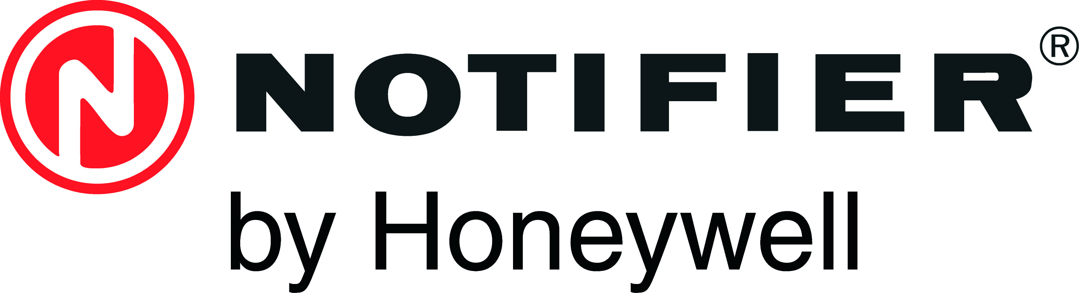
Liège Airport Business Park, B50  4460 Grâce-Hollogne  Belgium  Tel.: +32(0)4 247 03 00  Fax.: +32 (0)4 247 02 20  Web: www.notifier.be | Rietveldenweg 32a  5222 AR’s-Hertogenbosch  The Netherlands  Tel.: +31 (0)73 6273273  Fax.: +31 (0)73 6273295  Web: www.notifier.nl
Site Visit Request Form

Please complete this document and send by e-mail or fax to our Technical Department:
* for assistance in Belgium: +32(0)4 247 02 20 or supportfr.hlsbe@honeywell.com or supportnl.hlsbe@honeywell.com
* for assistance in The Netherlands: +31(0)73 6273295 or support.hlsnl@honeywell.com

Name: |  | Date of request: | 22/04/2014
Company: |  | Your HLS sales contact:
Phone number: |  | Your HLS technical contact:
Mobile number: |  | E-mail address: | .........@..........

Project details:
Facility name: |  | Date of installation:
Address:
Post code/Zip: |  | City:
Owner/End-user:

Installation details (please enter quantities or Yes/No):
Fire alarm panel |  | Field devices (sensors,modules,etc) |  | Repeaters/Network/Graphic PC
Others:

Problem description:
Name and Signature for approval:
- Site intervention rates: 0,6250€/km and 82,50€/hour with a minimum of 1 hour. (excl. VAT)
- With the subscription and sign off (or email confirmation), you accept the cost incurred with this intervention.
- After reception of this duly completed form, you will be contacted by Honeywell Life Safety to schedule a date for the site intervention.

This page is reserved to be filled in by Honeywell Life Safety - Technical Department:

HLS technical contact: |  | Date of intervention: | 22/04/2014
 |  | Time of arrival:
 |  | Time of departure:
 |  | Total Km:
Description of intervention:

Used materials:
Warranty or invoice:
Installation is:

Name and surname: | Company: | Signature:
* With the sign off of this document you agree with the above information and the conditions as stated in the latest price list, Chapter Practical Information Part 6i. (Services from HLS, Intervention on site).

